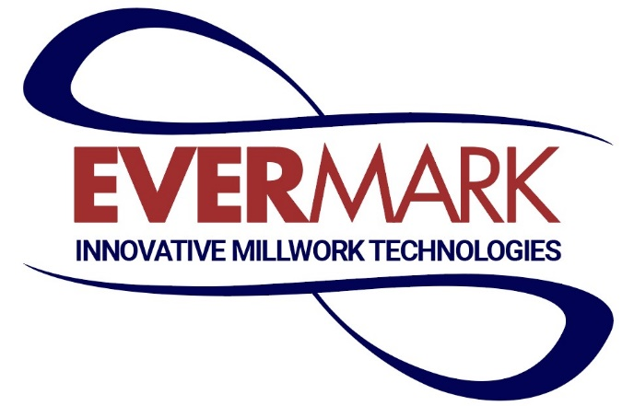

Ever wonder how it feels to go to work every day excited not just about what you do, but where you do it? At Evermark, you don’t have to wonder... our employees will tell you this can be your reality! Using your Production skills, to manufacture some of the finest quality handrail and treads in the stair parts industry.
If you’re passionate about what you do and inspired to do it better than anyone else, we can provide that playground, supporting you in ways you’ve never experienced. Even better—as an ESOP company, you’re helping to build a financially secure future not just for us.... but for yourself as well, as one of our owners!
With that in mind, if you’re at the top of your game—with the drive and energy to jump in with our dynamic team of go-getters—we want to hear from you!
Production Technician Job Description:
- Identify quality and productivity issues.
- Grading, feeding, repairing, rework, packaging are all functions that are required.
- Processing of raw material, work in process or finished good for shipment to customers.
- Complete required training.
- Support machine centers by moving blade rip system, RF gluing, moulders, and progressive prime line
- Demonstrate great teamwork.

To learn more about what we do at Evermark, visit our website at www.evermark-lnl.com.

