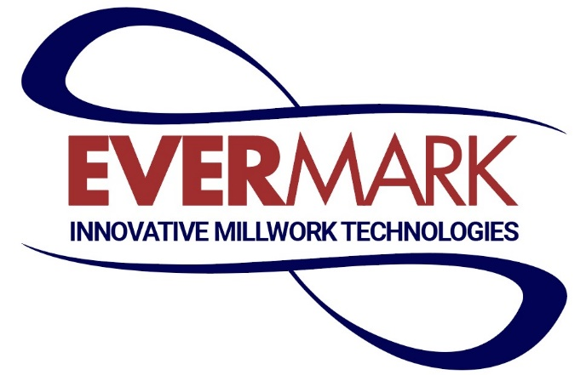

Ever wonder how it feels to go to work every day excited not just about what you do, but where you do it? At Evermark, you don’t have to wonder... our employees will tell you this can be your reality! Using your operating skills, to manufacture some of the finest quality handrail and treads in the stair parts industry.
If you’re passionate about what you do and inspired to do it better than anyone else, we can provide that playground, supporting you in ways you’ve never experienced. Even better—as an ESOP company, you’re helping to build a financially secure future not just for us.... but for yourself as well, as one of our owners!
With that in mind, if you’re at the top of your game—with the drive and energy to jump in with our dynamic team of go-getters—we want to hear from you!
Machine Operator Job Description:
- Performs all roles and responsibilities associated with the safe set up and operation of basic machine centers.
- Able to identify quality and/or productivity issues and take action to adjust machine center settings to correct them.
- Able to carry out all the functions of Production Support personnel without needing additional training.
- Carry out other assigned activities to support the processing of raw material, work in process (WIP), or finished goods so that they are ready for shipment to customers.
- Production Operators will primarily and routinely be assigned to roles that require moderate (< 2 months) training to perform at a satisfactory level. Machine centers to be operated by Production Operators include re-saw, chop saw, re-rip, double end tenoner, moulders, finger jointers and other similar machine centers.
- Demonstrate great teamwork.

To learn more about what we do at Evermark, visit our website at www.evermark-lnl.com.

