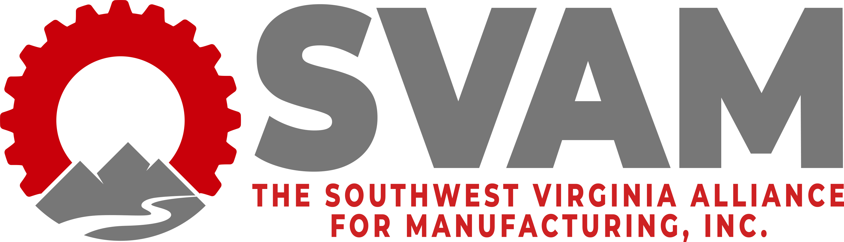

2022 Manufacturing Awards Banquet
Manufacturing Employee of the Year Award
Award Nomination Form
Deadline to Submit: September 20th, 2022

SVAM welcomes nominations for its first Manufacturing of the Year Award to be presented at its annual Manufacturing Awards Banquet on October 6th, 2022 in celebration of Manufacturing Month.
*Companies may nominate more than one individual.

Date: ______________________________

Nominator Contact Information:
Company Name: ______________________________
Name: ______________________________
Job Title: ______________________________
Phone Number: _____________________________
Email Address: _____________________________________

Nominee Contact Information:
Company Name (if different from nominator): ______________________________
Name: ______________________________
Job Title: ______________________________
Phone Number: _____________________________
Email Address: _____________________________________

Nomination Justification:
We received a very helpful list of qualities that many believe exemplify what it takes for an employee to be exemplary. We’ve condensed those suggestions to the following three categories. As you complete the nomination, please include as much detail as possible, placing emphasis on the aspects of each category that you believe are most important.

- Describe how the nominee demonstrates excellence in the area of Teamwork. Give specific examples.

- Describe how the nominee demonstrates excellence in the area of Commitment.

- Describe how the nominee demonstrates excellence in the area of Leadership. Give specific examples.

- Describe an outstanding individual achievement, contribution, or performance of their job and other related duties beyond their normal responsibility that has made a positive impact on the company.

- Explain why you believe this employee exemplifies what you believe qualifies an individual to be Employee of the Year. (This question is meant to summarize your nomination and will be used in the narrative for this employee’s award, should he/she be chosen as the overall winner.)

Scoring Rubric:
Teamwork: 25 Points
Commitment: 25 Points
Leadership: 25 Points
Company Impact: 25 Points

Send nomination forms to Lennie Gail Mitcham, SVAM Executive Director at lgmitcham@swvam.org or through fax at (276) 698-3152.
For any questions, please call the SVAM office at (276) 492-2100.

