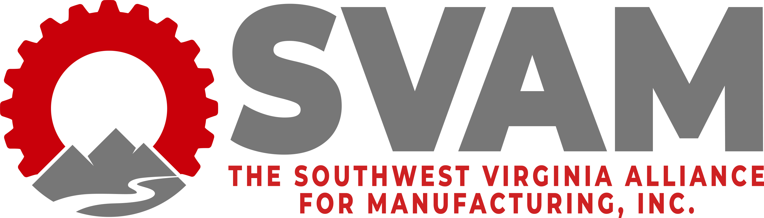

2022 Manufacturing Awards Banquet
Manufacturer of the Year Award
Award Application Submission Form
Deadline to Submit: September 20th, 2022

SVAM welcomes applications for awards to be presented at its annual Manufacturing Awards Banquet on October 6th, 2022 in celebration of Manufacturing Month. These awards recognize significant industry accomplishments as they positively impact the community.

Date: ______________________________

CONTACT INFORMATION:
Company Name: ______________________________
Contact Person’s Name: ______________________________
Contact Person’s Title: ______________________________
Phone Number: _____________________________
Email Address: _____________________________________
Mailing Address: _____________________________

CRITERIA:
Please refer to the following questions with a detailed response to those questions.

- Innovation: Describe innovation at the company during the past year. This can include include product development and growth, on-site production of innovative, award-winning “world class” products and/or services, safety programs, unique or innovative product designs/processes, recognized characteristics such as high-quality products, low defect rates, etc.

- Community Impact: Describe the company’s community impact efforts.
How has the company made key contributions to the quality of life in the community in which the company resides.

- Work Environment: Describe your company’s efforts to provide a quality work environment for its employees.

- Explain why you believe your company is deserving of this award. This response should be as inclusive as possible. Include examples and specifics. Include no more than 300 words.

Optional: List references or contacts that may be useful if the evaluators need additional information.

You may submit up to three pages, total, of supporting information to include charts or pictures.

Send nomination forms to Lennie Gail Mitcham, SVAM Executive Director at lgmitcham@swvam.org or through fax at (276) 698-3152.
For any questions, please call the SVAM office at (276) 492-2100.

