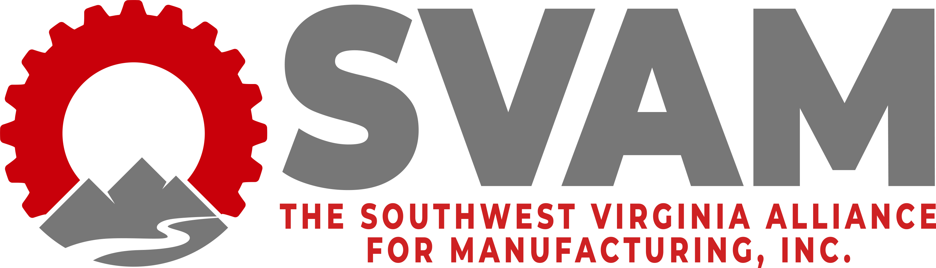

2022 Manufacturing Awards Banquet
Community's Choice Award
Award Application Submission Form
Deadline: September 20th, 2022

SVAM welcomes applications for awards to be presented at its annual Manufacturing Awards Banquet on October 6th, 2022 in celebration of Manufacturing Month. The Community Choice Award seeks to recognize manufacturers who have made a positive impact in their community.

Please do not submit self nominations for this award.

Name of Company Being Nominated: _____________________________
NOMINATOR:
Company/Organization: ______________________________
Name: ______________________________
Title: ______________________________
Phone Number: _____________________________
E-mail Address: _____________________________________
Mailing Address: _____________________________

NOMINATION:
Describe why you feel this company is deserving of recognition using as much detail and information as possible.

Optional: List references or contacts that may be useful if the evaluators need additional information.

You may submit up to three pages, total, of supporting information to include charts or pictures.

Send nomination forms to Lennie Gail Mitcham, SVAM Executive Director at lgmitcham@swvam.org or through fax at (276) 698-3152.

For any questions, please call the SVAM office at (276) 492-2100.

