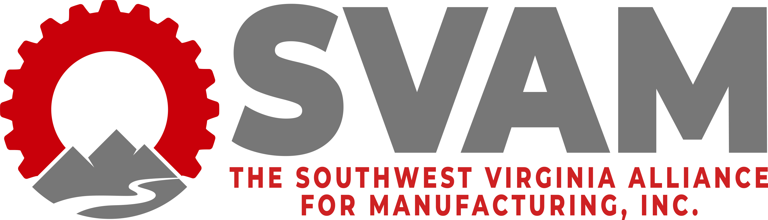

2021 Manufacturers’ Awards Banquet
Environmental Excellence Award
Award Application Submission Form
Deadline: September 17th, 2021

SVAM welcomes applications for awards to be presented at its annual Manufacturers’ Awards Banquet on October 14th, 2021 in celebration of Manufacturing Month. The Environmental Excellence Award seeks to highlight the great efforts of manufacturers to care for environment they operate in.

Date: ______________________________

CONTACT INFORMATION:
Company Name: ______________________________
Contact Person’s Name: ______________________________
Contact Person’s Title: ______________________________
Phone Number: _____________________________
Email Address: _____________________________________
Mailing Address: _____________________________

Please refer to the following questions and provide a detailed response to those questions that are applicable. Please only include programs and initiatives specific to the company branch(es) located in Southwest Virginia.
- Describe your company’s successful and innovative efforts to improve the environment.

- How will the project continue to be sustained?
- Tell us why you believe your company is deserving of this award. This response should be as inclusive as possible. Include examples and specifics. Include no more than 300 words.

Optional: list references or contacts that may be useful if the evaluators need additional information.

You may submit up to three pages, total, of supporting information to include charts or pictures.

Send nomination forms to Lennie Gail Mitcham, SVAM Executive Director at lgmitcham@swvam.org or through fax at (276) 698-3152.
For any questions, please call the SVAM office at (276) 492-2100.

