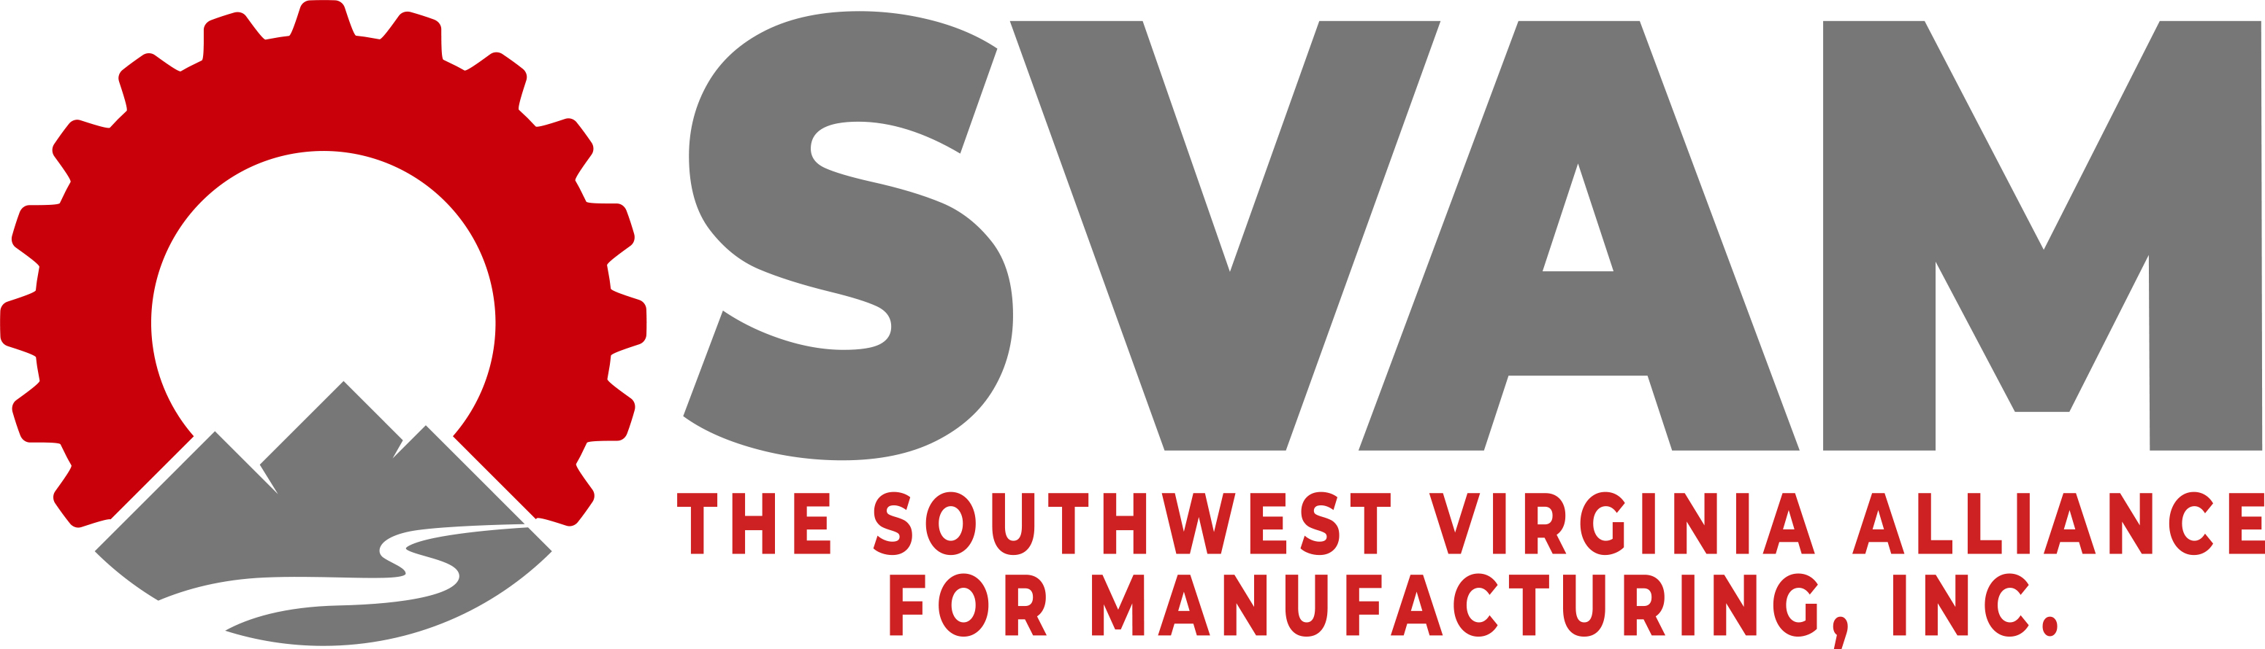

2021 Manufacturers’ Awards Banquet
Community Impact Award
Award Application Submission Form
Deadline: September 17th, 2021

SVAM welcomes applications for awards to be presented at its annual Manufacturers’ Awards Banquet on October 14th, 2021 in celebration of Manufacturing Month. The Community Impact Award seeks to recognize manufacturers who have made a positive impact in their community.

Date: ______________________________

CONTACT INFORMATION:
Company Name: _____________________________
Contact Person Name: ______________________________
Contact Person Title: ______________________________
Phone Number: _____________________________
E-mail Address: _____________________________________
Mailing Address: _____________________________

Please refer to the following questions and provide a detailed response to those questions that are applicable. You may choose to highlight one particular program, or provide a focus on all community impact efforts. Please only include programs and initiatives specific to the company branch(es) located in Southwest Virginia.

- Describe your company’s efforts and programs to positively impact/give back to the community.

- Tell us about your employees’ engagement in this/these programs.

- Use this space to provide additional information about why you believe your company is deserving of this award. This response should be as inclusive as possible. Include examples and specifics. Include no more than 300 words.

You may submit up to three pages, total, of supporting information to include charts or pictures.

Send nomination forms to Lennie Gail Mitcham, SVAM Executive Director at lgmitcham@swvam.org or through fax at (276) 698-3152.

For any questions, please call the SVAM office at (276) 492-2100.

